English Grammar – Prepositions in/on/at

1. Time Expressions

Reference:
IN century, decade, year, season, months
ON weekend, day of the week, specific day, date
AT night, time

Examples:
- in the 20th century / in the 1970s / in 1984 / in the winter / in August
- on the weekend / on Monday / on Christmas Day / on July 4th
- at night / at 10 o’clock

Others: in the morning / in the afternoon / in the evening
on Monday morning / on Tuesday afternoon / on Friday evening / on Sunday night

2. Place Expressions

Reference:
IN continent, country, state, city, neighborhood
ON avenue, road, street
AT address

Examples:
- in Asia / in Brazil / in Florida / in Chicago / in Manhattan
- on Acacia Avenue / on Hurricane Road / on Green Street
- at 24 Green Street

Others: on the right / on the left
at home / at work / at school / at the bank / at the pharmacy

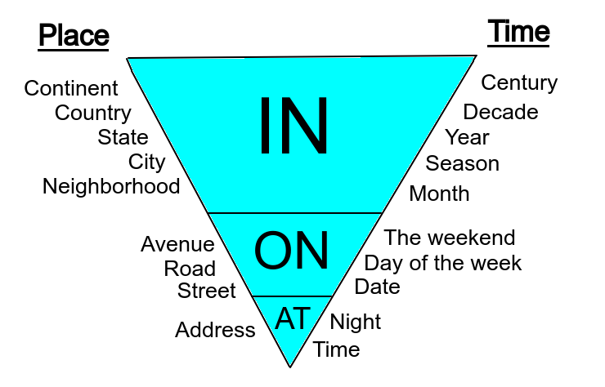

Suggested video: https://www.youtube.com/watch?v=l3pyRoXnNtg (12 mins)

Exercise 1. Prepositions of time (in, on, at).
1. Jane will arrive ___ January 26th ___ 9 o'clock ___ the morning.
2. Fred will go to the airport ___ Friday ___ midday.
3. I was born ___ 1987.
4. It's tradition to kiss your partner ___ midnight ___ New Year's Eve.
5. The telephone was invented ___ 1874.
6. The flight leaves tomorrow ___ 3:15 ___ the afternoon.
7. Let’s go to the beach ___ the weekend.
8. I love to watch TV ___ night.
9. I go to bed ___ 10pm every night.
10. We have English class ___ Tuesdays.
11. I will go to Paris ___ spring.
12. I always go to the cinema ___ my birthday.
13. I will call him ___ Wednesday morning.
14. Let's go to the cinema ___ the weekend.
15. Let's go to church ___ eleven o'clock ___ Sunday.
16. My birthday is ___ August 21st.
17. The meeting starts ___ 9:00 a.m.
18. I usually wake up early ___ the morning.
19. We moved to São Paulo ___ 2018.
20. My English class is ___ Mondays.
21. My wife was born ___ March 12th.
22. Let’s talk ___ lunchtime tomorrow.
23. They got married ___ the summer.
24. The train arrives ___ night.
25. He has an important exam ___ Friday morning.
26. We started this company ___ 1998.
27. The flight leaves ___ midnight.
28. We have a holiday ___ December 25th.
29. I prefer to work ___ the afternoon.
30. She called me ___ Thursday night.
31. I always watch TV ___ Sunday evening.

Exercise 2. Prepositions of place (in, on, at).
1. A: Where is John? B: He is ___ the pharmacy.
2. There are many castles ___ Europe.
3. A: Where is the library? B: It’s ___ the right.
4. Mary lives ___ Germany.
5. A: Where is John? B: He is ___ work.
6. A: Where are the kids? B: They are ___ the mall.
7. My parents live ___ a good neighborhood.
8. Where is Susan? She is ___ home.
9. My family lives ___ New York.
10. A: Where is Mary? B: She is ___ the drugstore.
11. My kids are ___ school today.
12. My boss was born ___ Texas.
13. My office is ___ Miami.
14. I live ___ Daffodil Avenue.
15. A: Where is the bank? B: It’s ___ the left.
16. My girlfriend lives ___ 21 Brown Street.
17. A: Where is Sue? B: She is ___ the post office.

